Software Requirements Specification

for

Chitra Gupta

The accounting Software

**Prepared by****:**

**CH V S Anirudh**

**A Shiva Kaushal**

**T K Subramanyam**

**K V S Sidhartha**

**J Vinay Shankar**

**Table of Contents**

**Table of Contents ii**

**Revision History ii**

**1. Introduction 1**

1.1 Purpose 1

1.2 Document Conventions 1

1.3 Intended Audience and Reading Suggestions 1

1.4 Product Scope 1

1.5 References 1

**2. Overall Description 2**

2.1 Product Perspective 2

2.2 Product Functions 2

2.3 User Classes and Characteristics 2

2.4 Operating Environment 2

2.5 Design and Implementation Constraints 2

2.6 User Documentation 2

2.7 Assumptions and Dependencies 3

**3. External Interface Requirements 3**

3.1 User Interfaces 3

3.2 Hardware Interfaces 3

3.3 Software Interfaces 3

3.4 Communications Interfaces 3

**4. System Features 4**

4.1 System Feature 1 4

4.2 System Feature 2 (and so on) 4

**5. Other Nonfunctional Requirements 4**

5.1 Performance Requirements 4

5.1 Performance Requirements 6

5.2 Safety and Security Requirements 5

5.3 Software Quality Attributes 5

**6. Other Requirements 5**

**Appendix A: To Be Determined List** 6

# Introduction

## Purpose

The purpose of the document is to build an accounting software which enables the organization to manage their accounts in an easy and efficient manner. This application is specially designed for the Karunya-Sindhu orphanage according to their requirements.

## Document Conventions

*Karunya Sindhu and Karunya Bharathi are the names of the orphanage for which the accounting software is being developed. The document is according to the srs_template from ieee.*

## Intended Audience and Reading Suggestions

*This application is an accounting software specially tailored according to the requirements of the Karunya – Sindhu orphanage. This document contains different features and options that our application is intended to provide. It contains an overall description of the application and all the requirements of the user along with the product scope.*

## Product Scope

*The project aims to digitalize the accounting database of the orphanage by developing a simple, user – friendly application which enables the accountant to give input, manage, manipulate, and obtain various reports for their analysis. The application also aims at maintaining the authenticity of the data entered by implementing features like 2-step verification.*

## References

*PFA, the documents regarding the different formats of data entry and schemes related to the orphanage.*

[*https://drive.google.com/file/d/1CKGtUHyM7RMSuOm7fXvca9iO9LjAN1zS/view?usp=sharing*](https://drive.google.com/file/d/1CKGtUHyM7RMSuOm7fXvca9iO9LjAN1zS/view?usp=sharing)

# Overall Description

## Product Perspective

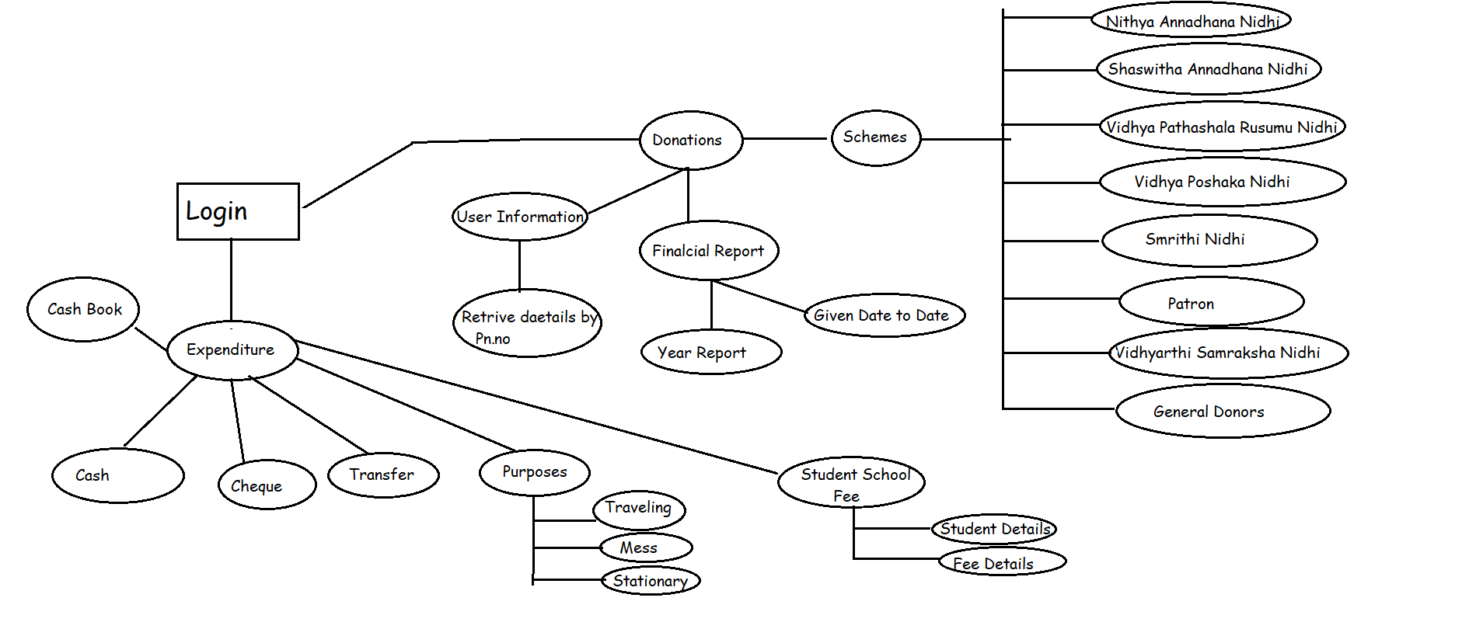

## Product Functions

*There are multiple functions that the application offers. It can mainly be divided into 3 sections.*

* *Donations – In this section all the data regarding the donations made to the orphanage are maintained and segregated according to the different schemes that the orphanage has. We intend to maintain a database where the user can store all the information regarding the donor and type of donation.*
* *Cashbook – It has all the options according to the requirements, there two different cashbooks which are handled i.e., Petty cashbook and the main cashbook. The information is captured according to the format given, and has many options to generate different reports and track their expenditure in an efficient manner.*
* *Bank Statement – This section provides them a space to record their bank-statements from their different accounts and provides them a means through which they can cross-check their expenditure and bank-statements.*

## User Classes and Characteristics

*There are two main user classes for this application.*

* *Normal User – The normal user has a different login i.e., normal login from where he/she can record all the data into a temporary database and also can view the main database and different remainders regarding the donors and donations.*
* *Master User – The master user has his own login i.e., the master login from which he/she can cross check the data entered by the normal user and verify the authenticity of data. Once he grants the permission the data from the temporary database is appended to the main database. He has permission to edit, append, manipulate any data in the database.*

## Operating Environment

*Operating Environment for the Chitra Gupta the accounting software is as follows –*

* *Operating System – Windows*
* *Database – MySQL*
* *Platform – Python 3*

*\*\*MySQL connector has to installed. \*\**

## Design and Implementation Constraints

*The frontend of the application is being developed using the PyQT5 library available for the python. We are mostly focusing to use python as the user is well adapted to python language and is going to maintain the application.*

## User Documentation

*A detailed demonstration of the different features that the application offers will be given to the user.*

## Assumptions and Dependencies

*The Donors are specially identified according to the phone number provided by them (according to the given requirements) hence it is assumed that the donor gives the same phone number when he visits again to donate.*

# External Interface Requirements

## User Interfaces

*This application has mainly 3 sections as listed in the Section 2.2. The user interface will be developed according to the requirements given, in a user-friendly manner. The user interface would adapt to different screen sizes and aspect ratios, and will be aimed at making things simple for the user.*

* *Donations Interface – In the interface the user can record any new donation made and can also view all the donations made earlier between any time frame he wishes to. The reports will be generated according the user’s needs.*
* *Cashbook Interface – In this interface the user can record all his credits and debits by filling in the information in the different field (according to the formats given by user) and append it to the existing database by clicking on the “append” button. There will be options provided in the interface by which the user gets access to track his expenditure.*
* *Bank Statements – Here the user will be provided with options to choose the bank account to which he wants to update. The user can view all the previously recorded statements, append new statements and can also view the account balance.*

## Hardware Interfaces

*The application works on Windows operating systems. The user needs the machine to be equipped with a scanner so that he/she can store any receipts, bills, etc. in the database. No other special hardware is required.*

## Software Interfaces

*The application completely works offline in Windows operating systems, it requires python3, MySQL to be installed.*

## Communications Interfaces

*The communication Interface between the front-end (Python GUI) and backend (MySQL) has to be installed i.e., MySQL connector using the pip present in the python environment.*

# System Features

## Retrieving Donor Details

4.1.1 Description and Priority

As per the requirement each donor is uniquely identified by his/her phone number. The application is capable of retrieving all the data about the past donors by giving their phone numbers. This feature comes under high priority as it makes the task of the user easy and avoids overlapping and capturing same data multiple times.

4.1.2 Stimulus/Response Sequences

*When the user starts to record details regarding a donation made by donor, he/she is asked to enter the phone number of the donor and if he/she is an existing donor in the database rest of the details are retrieved and presented automatically.*

4.1.3 Functional Requirements

*Each donor has to be uniquely identified and mapped with his/her phone number. Ones the user enters the phone number of the application must first verify whether it has 10 digits, then search in the database for the donor details.*

## Donation Remainders

* + 1. Description and Priority

The application has to go through all the donations recorded by the user and give out remainders (asking the donor to donate again) according to the schemes to which the donors had made their previous donations.

* + 1. Stimulus/Response Sequences

The application provides a sub-section called remainders in the Donations section where in the list of donors who previously had donated for a particular time frame and is getting expired according to the different schemes are displayed.

4.2.3 Functional Requirements

Each donation has to be stored separately and be classified according to the different schemes. The time frame of the validity of the given scheme has to be recorded and tracked on a frequent basis to give out the remainders.

## 2 – Step Verification for all data entries

* + 1. Description and Priority

It is a high priority function which the user requires to ensure the authenticity of the data entered into the digital database. There are two different type of logins and the data entered from the data login is stored in a temporary database and is append to the main database once the master login approves it.

* + 1. Stimulus/Response Sequences

If the user gets into the application using the normal login the application provides him different data templates to enter the data according to the different sections and its requirements and provides him an option to send it for the verification.

If the user loges in from the master login, then the application shows him the data entered from the by the normal user and provides him an option called verify by which the data is appended to the main database.

* + 1. Functional Requirements

We have to maintain a temporary database for the normal user.

## Periodic report generation

* + 1. Description and Priority

The user needs a proper analysis to track and manage their expenditure and hence the reports are to be generated periodically based on different categories.

* + 1. Stimulus/Response Sequences

In the cashbook section the user has the required options to generate his/her reports by selecting one or many categories and give the time frame in which the user wants to track the expenditure.

* + 1. Functional Requirements

All the debits are to be categorized accordingly. Ex: food, fees, transport, clothing, etc.

# Other Nonfunctional Requirements

## Performance Requirements

*There are no special performance requirements, the application is assumed to be smooth and responsive.*

## Safety and Security Requirements

*The database can only be modified through the application provided.*

## Software Quality Attributes

*The application is designed to adapt new functionalities in the future whenever necessary.*

*Ex. It can accommodate multiple units (Karunya Sindhu & Karunya Bharathi)*

# Other Requirements

*The previously recorded data is required for the testing purpose.*

**Appendix A: To Be Determined List**

* *Accounting the physical asserts which are bought in the expenditure and cashbook separately.*